**CSA0562- DBMS**

- B. SHASHANK

192324123

Student ddl query:

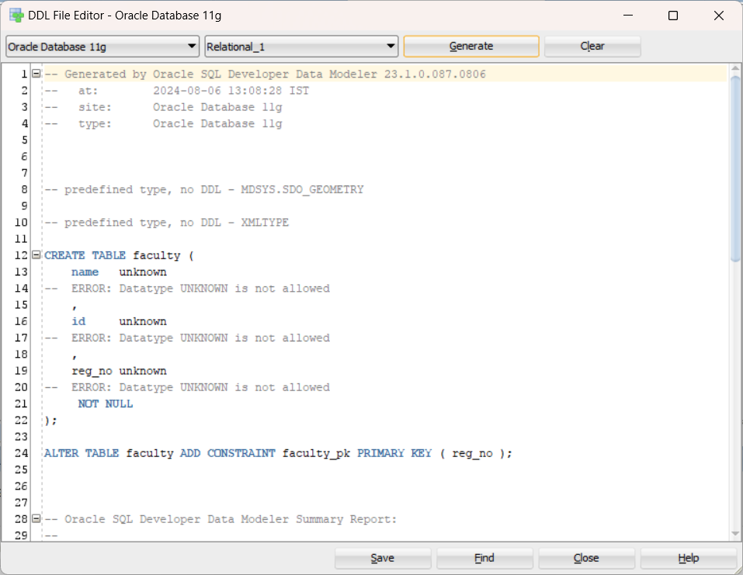

Course registration:

